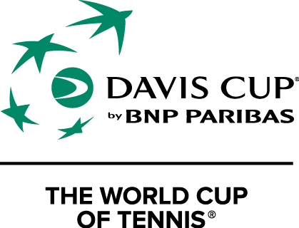

Davis Cup by BNP Paribas

2017 World Group Quarterfinal

Serbia v Spain
Hala “Aleksandar Nikolic” Belgrade
Friday 7 – Sunday 9 April 2017
MEDIA ACCREDITATION APPLICATION FORM

Deadline for Media Accreditation – Friday 31 March 2017

Media Organisation

Address

Country Postal Code

Emai

Telephone Fax

Name of applicant (family name) (first name)

Category

Writer Radio Photographer TV

Type
Daily newspaper Weekly newspaper Magazine Agency

Other ____________

Any individual requirements: (Radio position, TV...)

Deadline for Media Accreditation
Please send your accreditation form until 31. 03. 2017. to the:

E-mail: akreditacijetss@yahoo.com
Fax: +38111 7121899
Mob. +38164 6401204 PR STF Neda Miletic
For every journalist we will have a desk space in the media work area.

There will be free WiFi in the media work area.

We need a photo for accreditation.

Media hotel information:

Hotel HERITAGE ****
Mije Kovačevića 7a, Beograd
www.heritagebelgrade.com

Rate:
- Double room, singe use (king size bed, 23 m2) 60 €
- Double room, doubel use (king size bed or 2single beds, 23 m2) 70 €
- Junior suite (king size bed, 30 m2) 90 €

Room rate includes: accommodation, international buffet breakfast, free Wi-Fi in whole
hotel and VAT.

Contact for booking:

Milica Nešković
Sales Manager
Hotel HERITAGE ****
Mije Kovačevića 7a, Beograd
+38166 8884029
+38111 7151060
www.heritagebelgrade.com
group@heritagebelgrade.com

Deadline for booking: 1 April 2017

